**Steps Involved for downloading Acadgild VM and Importing it to oracle VM**

* Click on the link for downloading acadgild vm from your google drive.

<https://drive.google.com/file/d/0Bxr27gVaXO5sZi1XTkhkLUUxUmc/view>



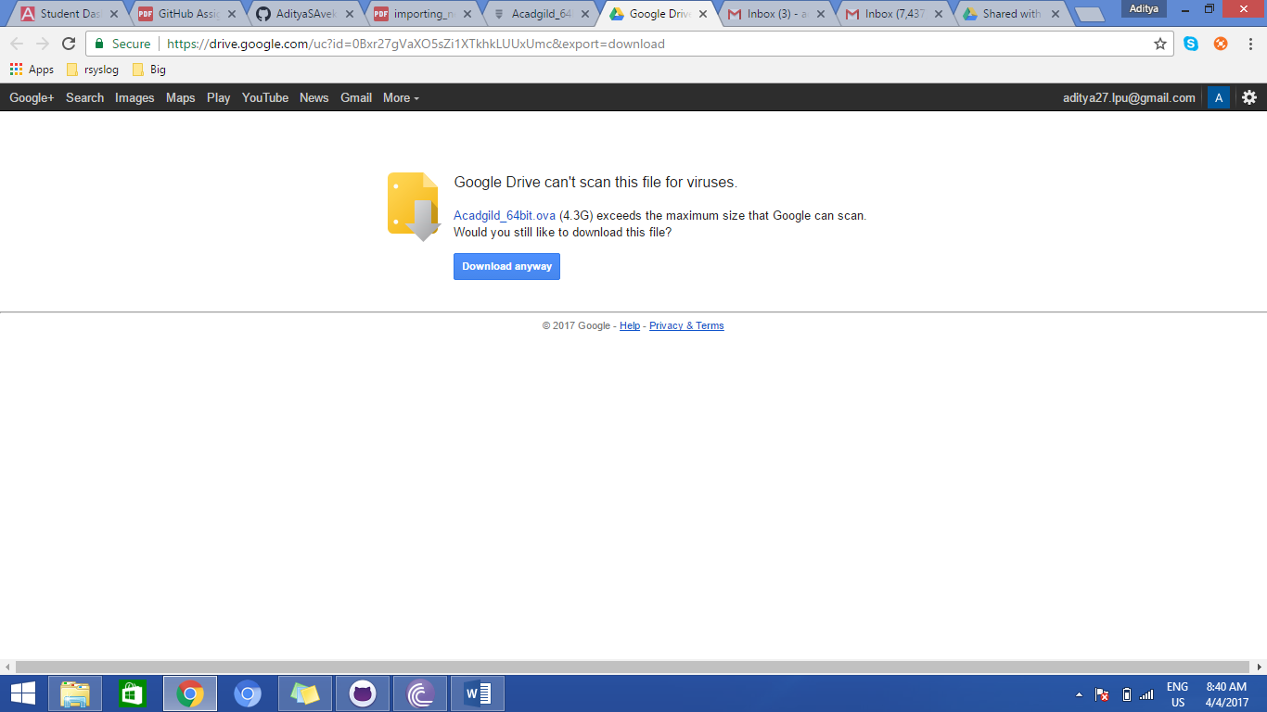

* Import the **acadgild VM** with .ova extention which you downloaded from the above link

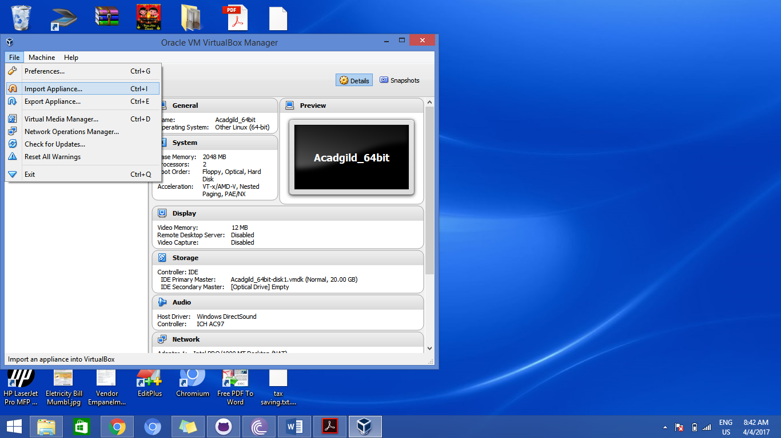

* Add the path of .ova file present on your system and click on Next.

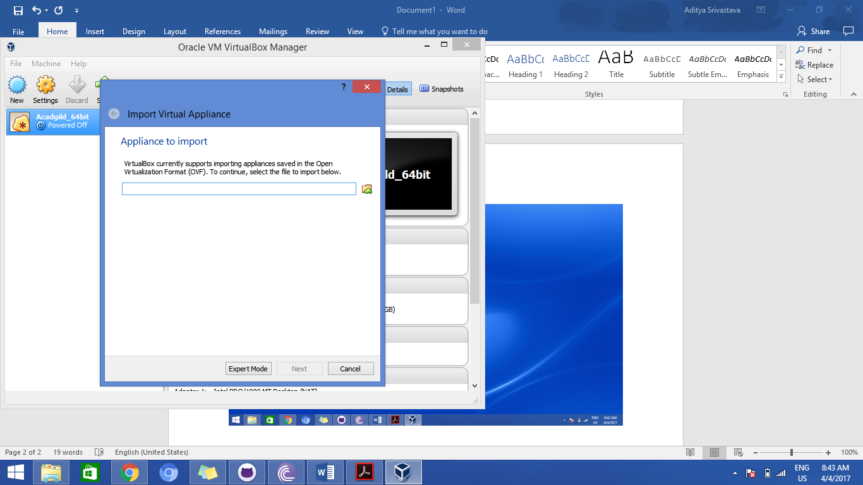

* Add the Application setting for the VM and click on import.

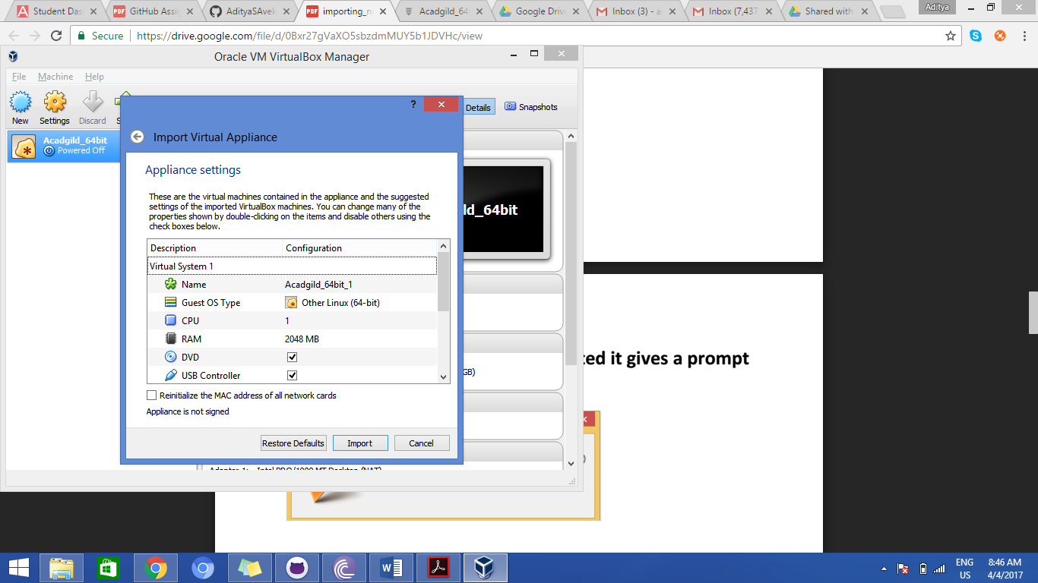

* Once all this is done, select your VM and click on start

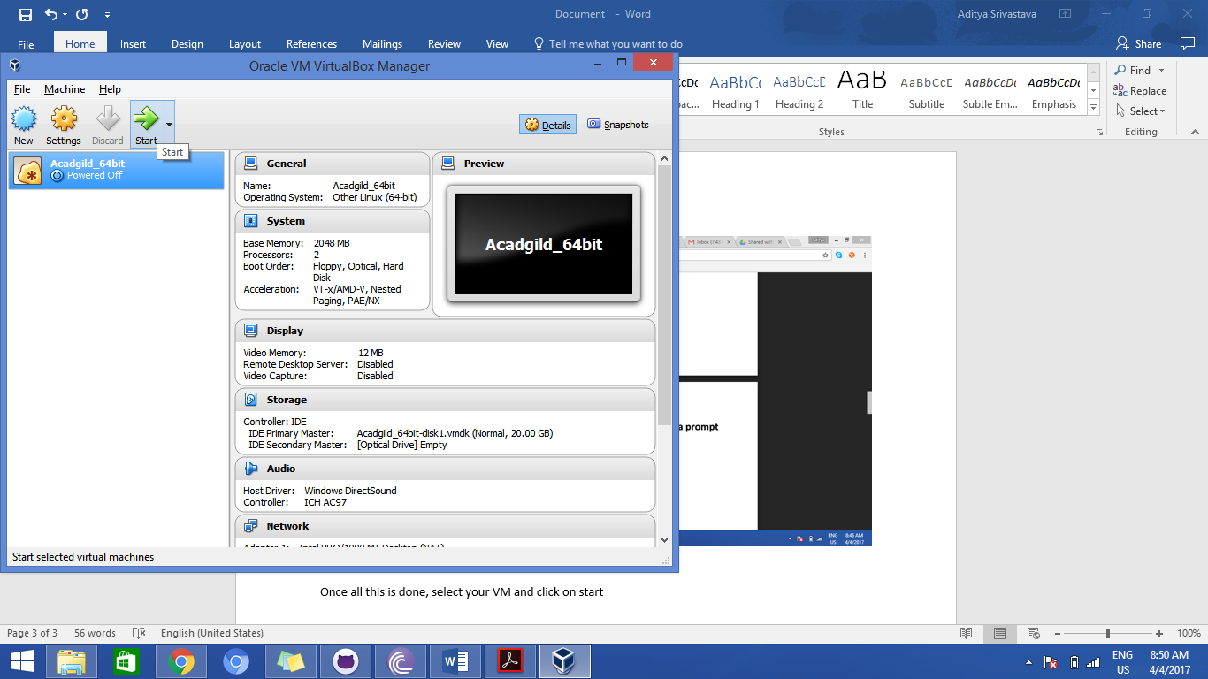

* You will see a username-acadgild
* Enter password- acadgild and you can start accessing your Virtual machine thereafter.